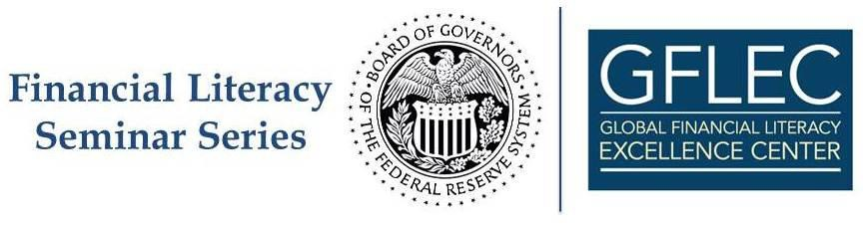

Trading Stocks Increases Financial Literacy and Compresses the Confidence Gender Gap

Agenda
March 21, 2019

The George Washington University
Duqués Hall, Room 451

TIME | SCHEDULE
3:30 pm | Opening Remarks  Michael Zabek, Federal Reserve Board
3:35 pm | Seminar Presentation  Saumitra Jha, Stanford Graduate School of Business
4:35 pm | Q&A
4:55 pm | Concluding Remarks  Annamaria Lusardi, GFLEC, George Washington University School of Business
5:00 pm –  6:00 pm | Reception  Duqués Hall, 4th Floor Lobby

